WEEK 1 – DSA

Exercise 2: E-commerce Platform Search Function

Scenario:
You are working on the search functionality of an e-commerce platform. The search needs to be optimized for fast performance.

Steps:

1. Understand Asymptotic Notation
- Study Big O notation to analyze algorithm efficiency.
- Understand Best Case, Average Case, and Worst Case scenarios.
2. Setup
- Create a Product class.
- Add attributes:
1.productId
2.productName
3.category
3. Implementation
- Implement Linear Search algorithm.
- Implement Binary Search algorithm.
- Store products in an array.
- Use a sorted array for Binary Search.
4. Analysis
- Compare the time complexity of both algorithms.
- Determine the most suitable algorithm for an e-commerce platform.

Solution Code:

Product.java

class Product {

int productId;
String productName;
String category;

public Product(int productId, String productName, String category) {
this.productId = productId;
this.productName = productName;
this.category = category;
}
}

SearchFunction.java

public class SearchFunction {

public static Product linearSearch(Product[] products, int targetId) {

for (Product product : products) {
if (product.productId == targetId) {
return product;
}
}
return null;
}

public static Product binarySearch(Product[] products, int targetId) {

int left = 0;
int right = products.length - 1;

while (left <= right) {

int mid = (left + right) / 2;

if (products[mid].productId == targetId) {
return products[mid];
}

if (products[mid].productId < targetId) {
left = mid + 1;
} else {
right = mid - 1;
}
}

return null;
}

public static void main(String[] args) {

Product[] products = {
new Product(101, "Laptop", "Electronics"),
new Product(102, "Mobile", "Electronics"),
new Product(103, "Shoes", "Fashion"),
new Product(104, "Watch", "Accessories"),
new Product(105, "Bag", "Fashion")
};

Product linearResult = linearSearch(products, 103);

if (linearResult != null) {
System.out.println("Linear Search Found: " +
linearResult.productName);
}

Product binaryResult = binarySearch(products, 104);

if (binaryResult != null) {
System.out.println("Binary Search Found: " +
binaryResult.productName);
}
}
}

OUTPUT

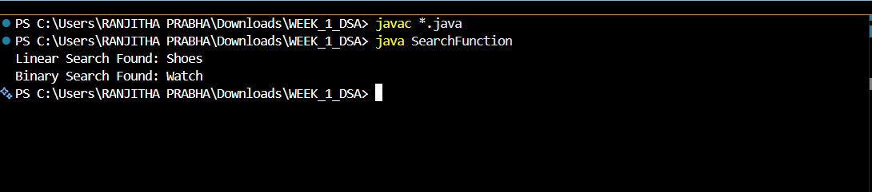

Exercise 7: Financial Forecasting

Scenario:
You are developing a financial forecasting tool that predicts future values based on past data.

Steps:
- Understand Recursive Algorithms
  - Recursion is a technique where a method calls itself to solve smaller instances of a problem.
  - It simplifies problems that can be broken down into repetitive subproblems.
- Setup
  - Create a method to calculate future values using recursion.
  - Use an initial investment amount and a growth rate.
- Implementation
  - Implement a recursive function that calculates the future value after a specified number of years.
- Analysis
  - Analyze the time complexity of the recursive algorithm.
  - Discuss optimization techniques.

Solution Code:

FinancialForecast.java
public class FinancialForecast {

public static double futureValue(double currentValue,
double growthRate,
int years) {

if (years == 0) {
return currentValue;
}

return futureValue(currentValue,
growthRate,
years - 1) * (1 + growthRate);
}

public static void main(String[] args) {

double currentValue = 10000;
double growthRate = 0.10; // 10%
int years = 5;

double result = futureValue(currentValue,
growthRate,
years);

System.out.println("Future Value after "
+ years + " years = "
+ result);
}
}

OUTPUT

